Overview:

The Hough Transform is a feature extraction technique that estimates parameters of a shape from its boundary points. Advantages of the Hough Transform include that it is scale-invariant, shift-invariant and rotation-invariant. It also functions well with added noise. Disadvantages include that it is computationally expensive and that it can falsely detect multiple instances of a single edge.

Approach:

The Hough Transform converts points in an edge picture to sinusoids in a parameter space expressed in polar coordinates.

These sinusoids are put into an accumulator. When two points are collinear, the sinusoids corresponding to the two points intersect at a point. These intersections form peaks in the Hough domain. The peaks in the accumulator tell us which features in an image are present. For example, a square has four Hough peaks, corresponding to each corner in a square.

Features that the Hough Transform can detect include lines, points, and curves such as circles and ellipses in images because these features have parametric representations.

Implementation:

1. Convert Image to binary scale
   1. The first step we need to do is to convert color images to binary images such that the only region of interest are the boundaries of shapes and not the varying colors the shape may have.

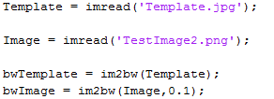

1. Given the binary image, we use the Matlab edge function to detect the edges



1. From the edges we compute the Hough Transform



1. Finally, we calculate the Hough peaks



Hough Transform of the Template (Square):

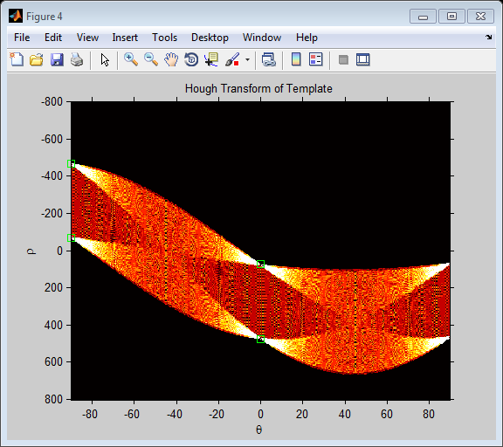

Results on various test images:

Test Image 1

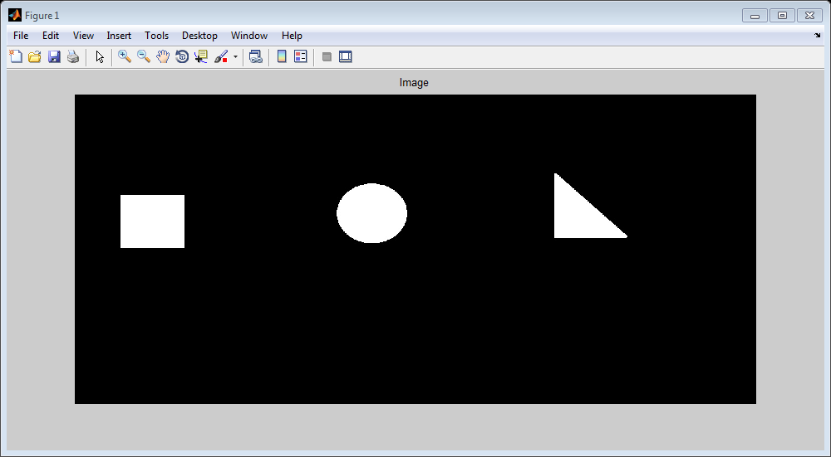

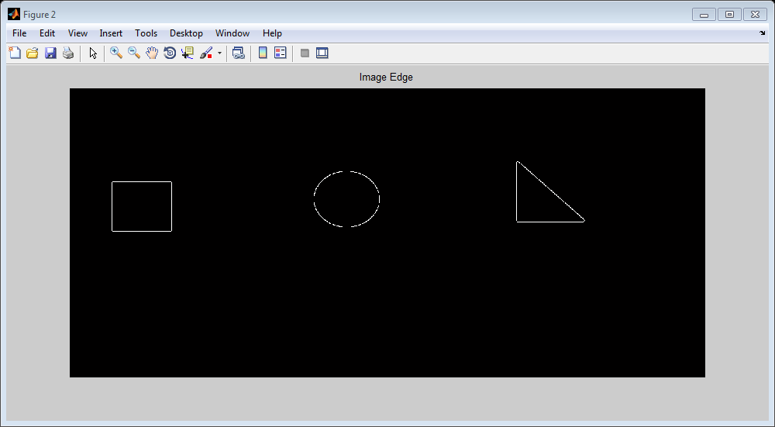

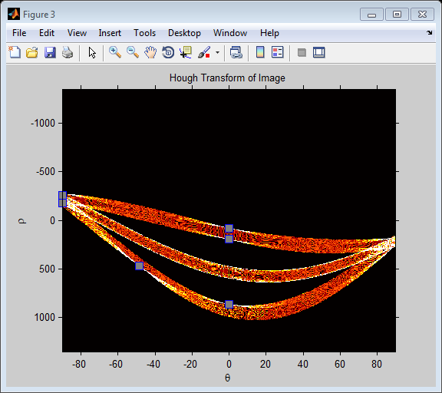

Test Image 1 (with 0.1% salt and pepper noise) (with 1% noise everything gets distorted)

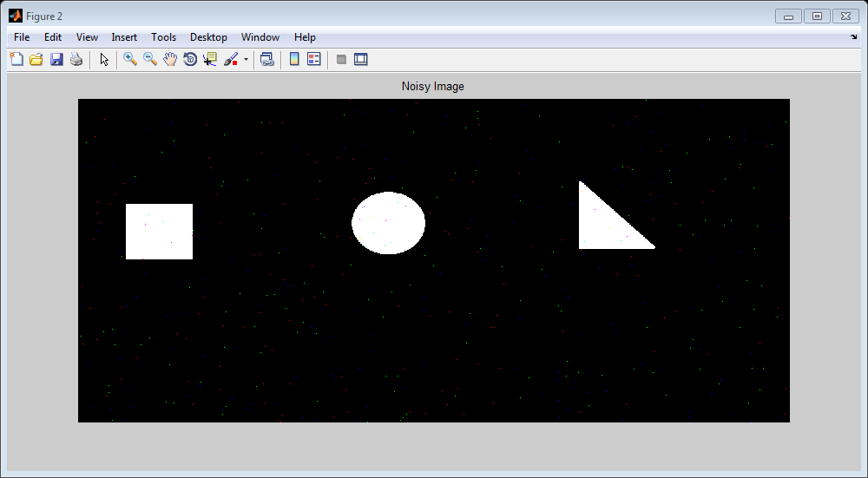

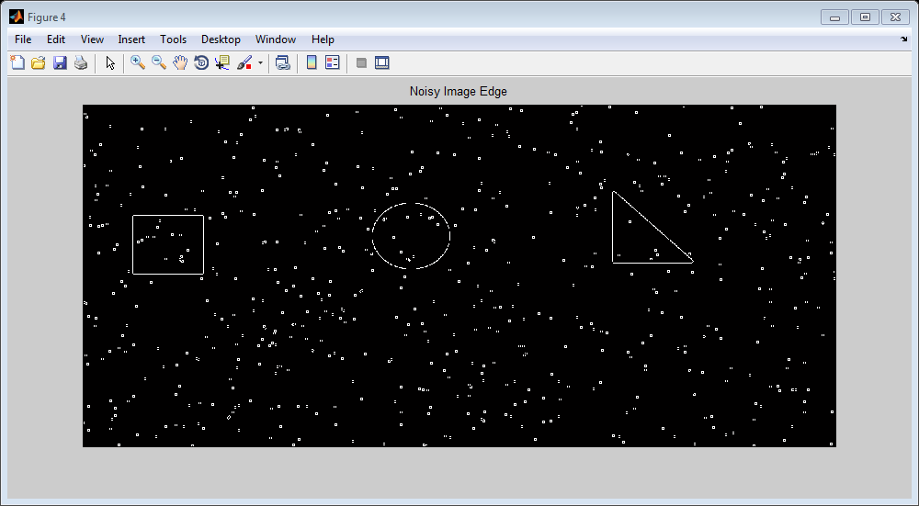

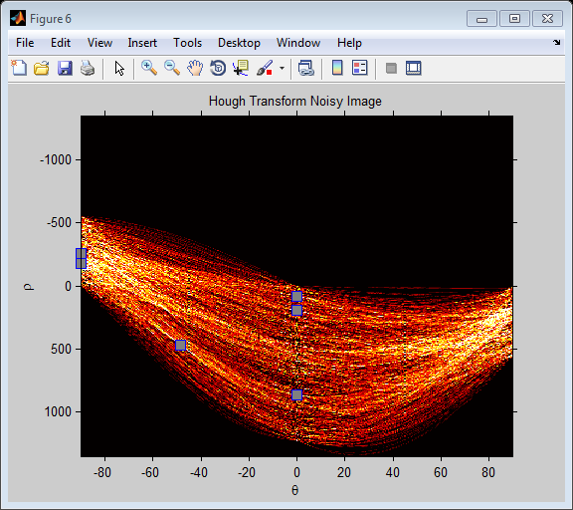

Test Image 2

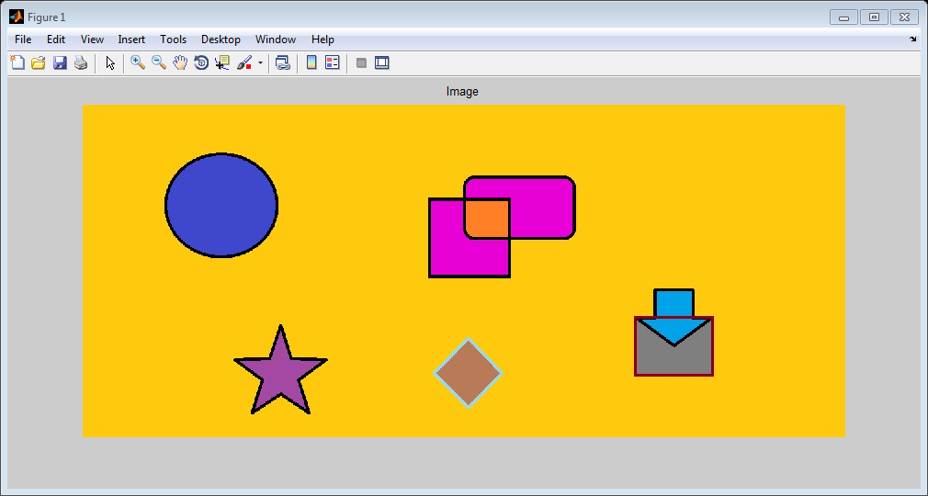

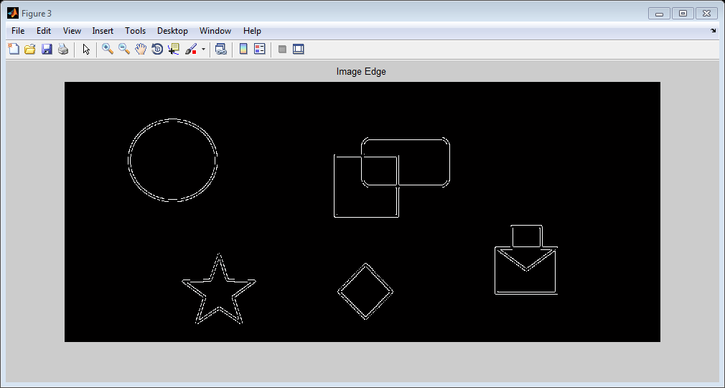

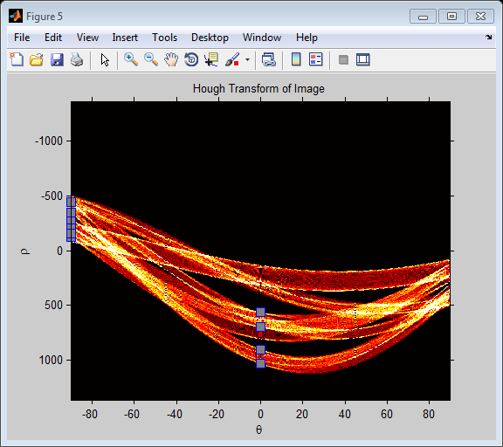

Test Image 2 with 0.1% salt and pepper noise

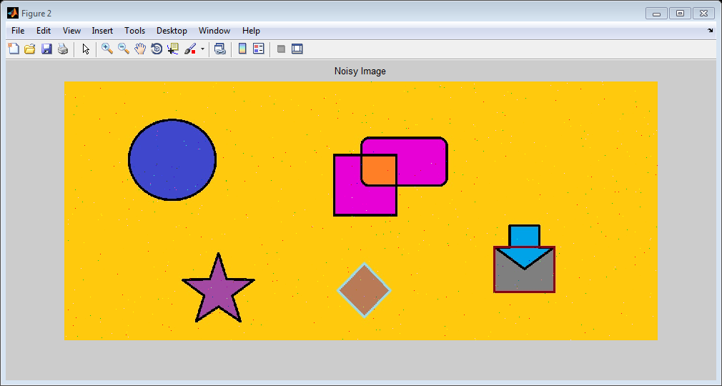

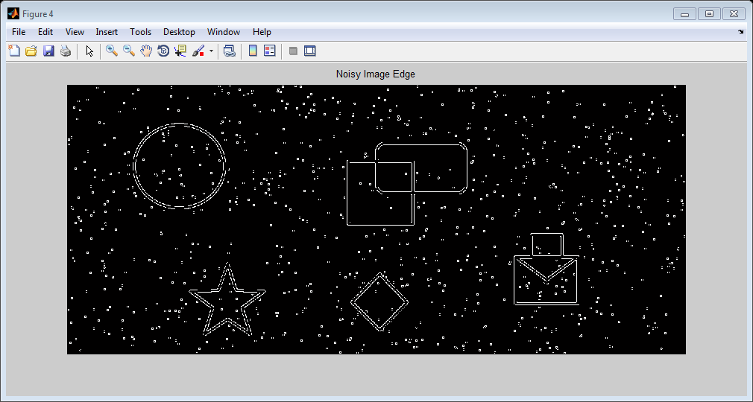

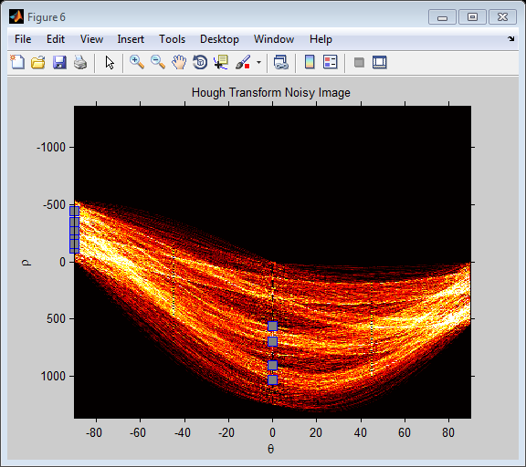

TestImage 3

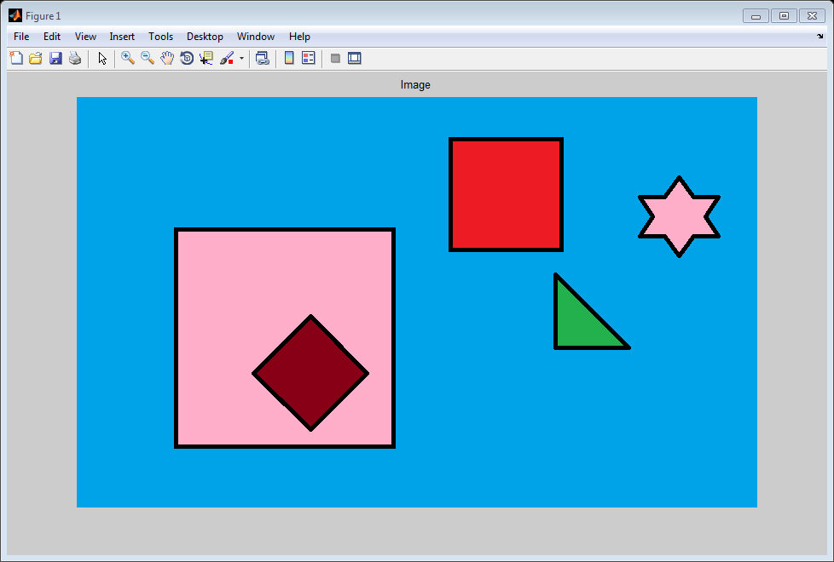

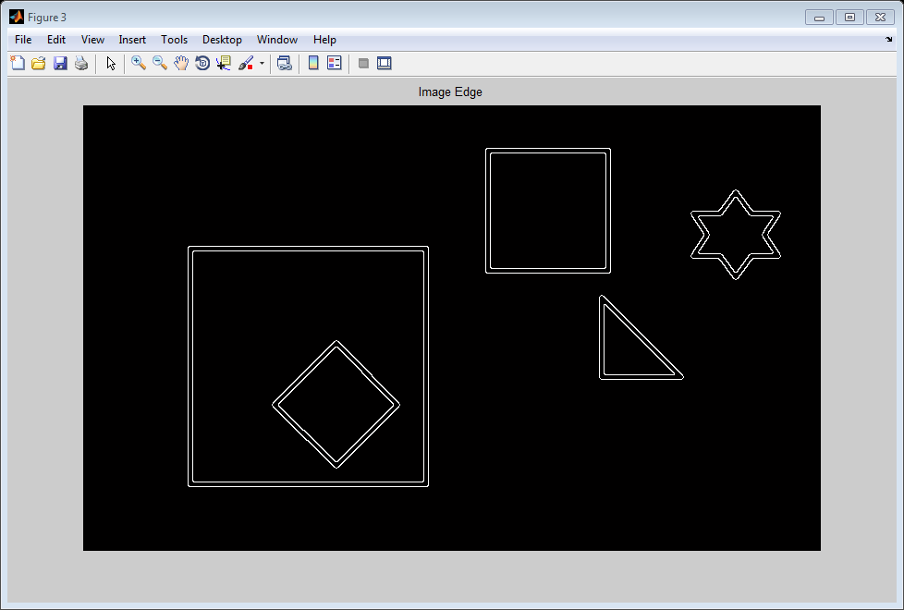

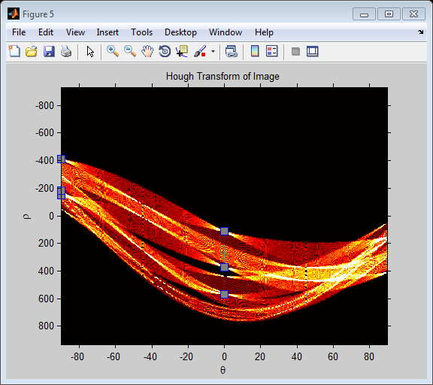

Test Image 3 with 0.1% salt & pepper noise

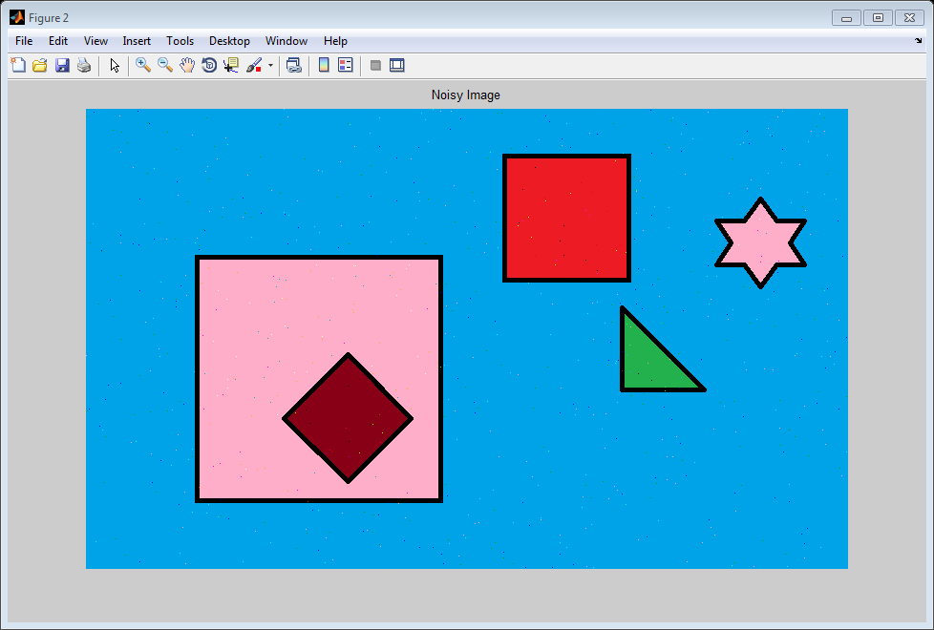

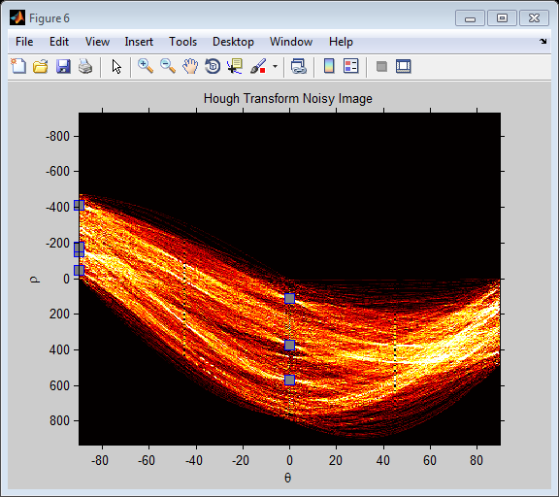

Test Image 3 with a Gaussian noise (zero mean, 0.001 variance)

